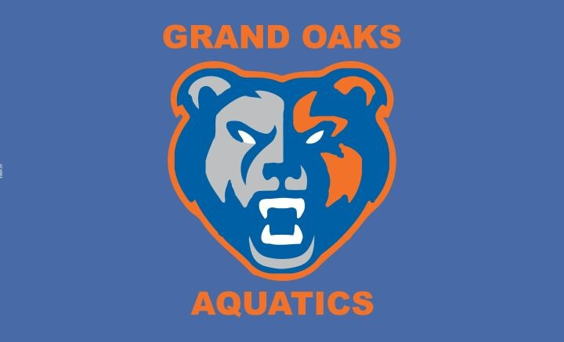

Families and Business Owners:
The Grand Oaks High School Swim and Dive Booster Club is a 501(c)(3) corporation that has been established to assist the student-athletes participating in the Swimming, Diving, and Water Polo programs at Grand Oaks High School.
It is this Booster Club’s mission to support the swim and dive athletes and coaching staff by:
- Providing financial support.
- Promoting and increasing team visibility.
- Increasing community and parent interest and involvement with the team.
- Recognizing the endeavors and achievements of the team as a whole, as well as, individual athletes.
- To help provide services and activities to help the team run efficiently and successfully while promoting school spirit.
In order to accomplish the above, we rely on registration fees from our families, hosting fundraising events, and seeking out local community sponsors which is the purpose of this letter. We are asking that you please consider donating to our organization to benefit our amazing swimmers and divers by choosing one of the sponsorship opportunities.

Thank you for your consideration, GOHS Swim and Dive Booster Club

GO White - $100.00
- Business logo & link on GOHS Swim & Dive website sponsor page
- Recognition in booster club membership communications
- Social media recognition
- Company name on team shirt
- Banquet program recognition

GO Orange - $250.00
- Business logo & link on GOHS Swim & Dive website sponsor page
- Recognition in booster club membership communications
- Social media recognition
- Company logo on team shirt (small logo)
- Banquet program recognition

GO Blue - $500.00
- Business logo & link on GOHS Swim & Dive website sponsor page
- Recognition in booster club membership communications
- Social media recognition
- Company logo on team shirt (large logo)
- Banquet program recognition
- Sponsorship plaque with team picture

I would like to participate at the
White
Orange
Blue sponsorship level.

Name Phone # Email Company Name (as you would like it to appear on signage)

Company Mailing Address

Please make checks payable to GOHS Swim and Dive Booster Club Please email business logo and website link to goswimdivebooster@yahoo.com
GOHS Swim and Dive Booster is a 5013c Charity, Tax ID is 83-253284 (Your donation may be tax deductible)
These proceeds will be used for the sole purpose and benefit of all of our awesome swimmers and divers at Grand Oaks High School

